What I Have Said, That Will I Do/Don’t Let Holidays Take You Off Prayer!
November 13, 2016
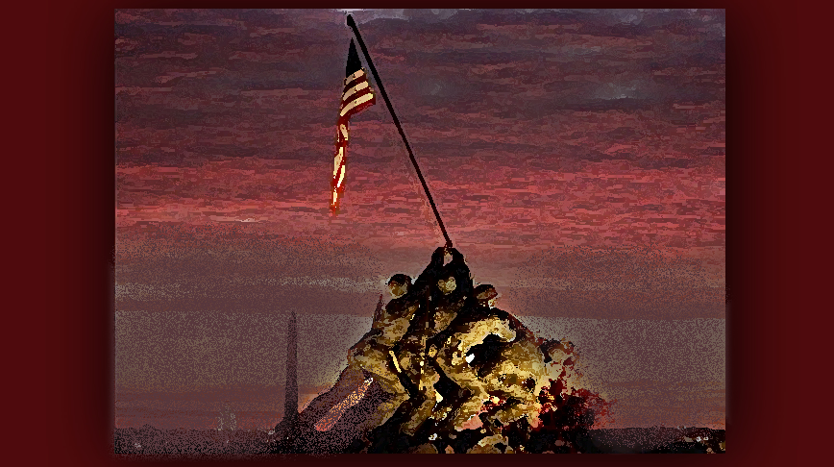
May the Love of the Lord Jesus keep you dear Heartdwellers and may Our Nation be transformed by the faith of Gideon’s 300 with the Lord at the helm.

Well, there must be some naysayers out there for the last message, because the Lord launched off immediately after prayers this morning. And I'm gonna share what He had to say.

The Lord Jesus began, "We live by faith, not by sight. What I have said, that will I do and nothing short of that. Those among you who think My arm is short and cannot accomplish what I want it to do, are thinking as man thinks, not God. Put on the mind of Christ, My people. Do not throw your lot in with the naysayers. As long as you continue to pray and offer sacrifices, My will shall be done in your nation, not at some future date - but now.

"Yes, I say the time is NOW. I will do wonders among people, especially the blind who have been so deep in a lethargic sleep, they cannot conceive of change. But I will change those things I have targeted that are not right. Yes, I will change them.

"But I am looking for Gideon’s 300. The rest of you can stay home. Those of you who know Me - stand by Me and be a force to be reckoned with. Man cannot withstand Me. Satan cannot withstand Me, for there is no power on Earth or in the heavens that can withstand their Creator. I have dominion over all.

"What I have said, I will surely do.

"Now, that clarified - I need you to stand with Me in prayer. This is the season when Satan looses avarice and greed to draw you away from Me and the true meaning of this tradition. I charge you, My Gideon force, do not be taken by distraction. It is a rule of engagement: distract the enemy and you can defeat them. Distractions are coming. Family, holidays, celebrations - all of that must be kept to a minimum as you fight the good fight in prayer.

"I am not saying you cannot gather with your family, but do not allow yourselves to be carried away by the spirit of Materialism, Gluttony, Acquisition and Greed. These are the demons loosed to bring you down My People. I have named them for you, take authority and renounce and bind these things from hindering you.

"Do you understand? The enemy is planning to use this against you, to defeat you and ultimately put in grave danger your loved ones. Surely, if he succeeds, evil will overtake this country.

"That is what has been planned for you, America. Staged riots and outbreaks of violence are being planned and even occurring as we speak. Yes, the enemy is hell-bent on destroying this administration before it takes office.

"There is only one way this is going to happen, and that is if you get distracted and stop praying, pouring your heart out to Me, crying out to Me to save you. If you stop praying - you lose.

"Do not allow the enemy to do this through sentimentality and greed. Every year I lose My Bride to these forces as she chases shopping malls and internet stores. Every year I must sit alone, waiting for My Bride while she shops and wraps presents. Every year.

"Will you abandon Me now too? This is My warning to you, heavy spirits of compulsion are going to be loosed on you to draw you away from the battlefield. If you fall, call on Me immediately and I will rescue and reinstate you.

"Every man counts in this battle. I only want My Gideons 300 - the ones who truly believe that I can do what I set out to do. And every single one of you count. Your lives, your faith, your family - indeed your future - lie in your praying hands. Do not be defeated by your own flesh.

"The current administration is fighting to keep the power. With your prayers they will be unseated and My servant will be the Victor. But it will not be done without your prayers and sacrifices.

"And again, I remind you, every little suffering can be offered to the Father for this battle. Someone took your parking place? Now you have to walk further? Offer it up. Someone treated you rudely? Offer it up. You awoke with a headache, you lost something? Offer it up. For truly, I say to you, NOTHING is too small to offer Me. You are in a battle and every shot fired counts.

"I will arrange circumstances that are frustrating to you, you don’t have to go looking for them.

"Remember, nothing happens without My consent. No matter what it is, it has value, sometimes a little and sometimes a lot. It all matters, and your demeanor matters as well. Are you suffering and grumbling and complaining? Or are you rejoicing that another bullet has taken the enemy down? For surely, these sacrifices are like shots fired that go straight to the target, bringing it down. Guiding the offerings to their mark is My part of the job.

'Go now in faith, My beloved Bride, believing that what I have said I will do, because you are faithful to pray. And do not allow the enemy to distract you.

"I am with you in a powerful way and we are doing this together."

